: The Shockley Diode Equation

Introduction
This appendix is concerned with the derivation of Shockley equation, which describes the relation between current and voltage for the ideal p-n junction i.e. current flow due to diffusion only. Furthermore, the physical meaning of the ideality factor n described with reference to the dominant current transport mechanism operating in the junction.

Shockley equation and the ideal p-n junction
The main assumptions for the ideal p-n junction which are embodied in the Shockley equation are [1]:
- The junction is abrupt.
- Botlzmann approximation is valid throughout the depletion region.
- Low injection conditions apply.
- No generation current presents in the depletion region.
- Both electron and hole currents are constant through the depletion region.
Since two charge carriers contribute to currents in semiconductors, electrons and holes, the current depends on their concentration in the conduction and valence bands for electrons and holes respectively. These concentrations are determined by considering the position of the Fermi level (E_{F}), which is defined as the energy level above which all energy levels are empty whereas they are filled below it at T = 0 K.
If the semiconductor is pure i.e. without impurities and defects, then it is called intrinsic semiconductor, in which the Fermi level is called the intrinsic Fermi level (E_{Fi}), and is located close to the middle of E_{g}. Electron and hole concentrations are both equal to the intrinsic carrier concentration (n_{i}) in this case.
However, in case of doping for example, E_{F} changes its position and becomes closer to the conduction and the valence band for n-type and p-type materials respectively, as shown in. At thermal equilibrium e.g. without external applied voltage or change in temperature for example, the equilibrium carrier concentrations for electrons, n₀ and holes, p₀ are given by

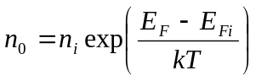 (‎B.1)

and

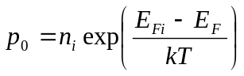 (‎B.2)

where k is Boltzmann’s constant and T is temperature.

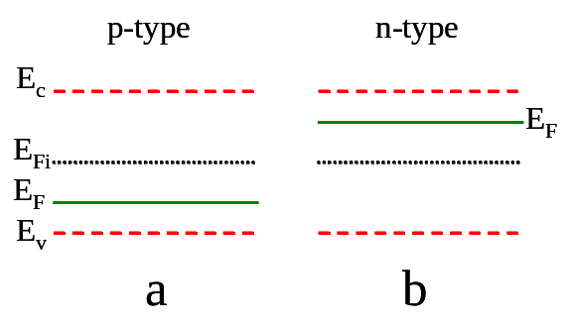

Figure ‎B.1: Band diagrams for a) p-type and b) n-type semiconductors. The figure shows the intrinsic Fermi level (E_{Fi}), and the change in its position (to E_{F}) within E_{g} as doping changes.

When a p-n junction is formed, the Fermi level must be aligned across the device as discussed in Section 2.1 i.e. the Fermi level has the same value across the whole device. However, its position may be disturbed if there are excess carriers due to an external voltage or thermal excitation for example. The new position for the Fermi level is called the quasi Fermi level, and denoted as E_{Fn} and E_{Fp} for n- and p-sides of the device respectively (). The new carrier concentrations, including the excess carriers are expressed as

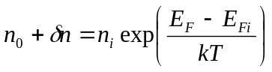 (‎B.3)

and

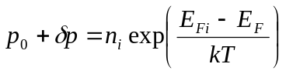 (‎B.4)

for the n- and p-sides respectively, where n and p are the excess electron and hole concentrations.
The excess hole concentration (minority carriers) within the n-side of the device is given by [2]

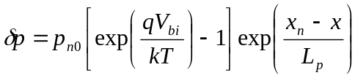 (‎B.5)

where V_{bi} is the built in potential in the junction, p_{n0} is the equilibrium minority carrier hole concentration, L_{p} is the hole diffusion length and x_{n} is the distance between the centre of the depletion region and the end of it in the n-side as seen in Figure ‎B.2.

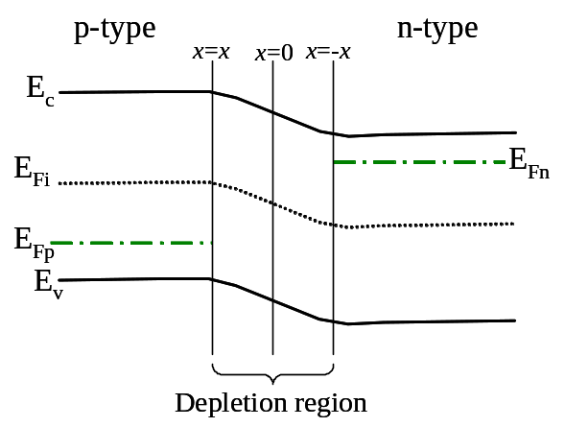

Figure ‎B.2: A p-n junction showing the quasi Fermi levels for both n- and p-side, E_{Fn} and E_{Fp} respectively.

The hole diffusion current J_{p} at x = x_{n} can be calculated from the equation [2]

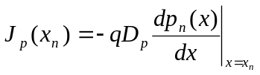 (‎B.6)

where D_{p} is the hole diffusion coefficient, q is the electronic charge and p_{n} is the minority carrier hole concentration in the n-side of the device. Since doping is assumed to be uniform, p₀ is constant. Hence by using equation B.4, equation B.6 can be rewritten as

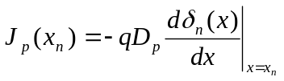 (‎B.7)

By deriving equation B.5 and then substituting in equation B.7,

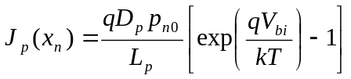 (‎B.8)

By the same argument for minority carrier electron in the p-side, the electron diffusion current J_{n} at x = - x_{p} can be expressed as

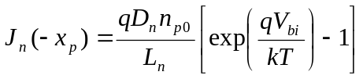 (‎B.9)

where D_{n} is the electron diffusion coefficient, and n_{p0} is the minority carrier electron concentration.
The total current in the junction (as it is mentioned in the assumptions earlier in this Section) is the sum of both electron and hole minority currents i.e. the total current J is the sum of J_{p} and J_{n}, therefore it can be written by using equations B.8 and B.9

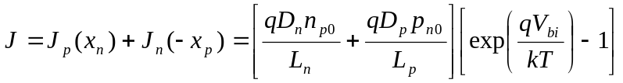 (‎B.10)

or

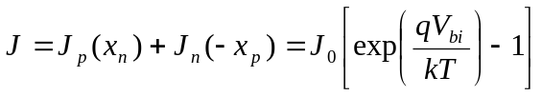 (‎B.11)

where

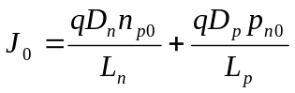 (‎B.12)

J₀ is called the saturation current. Equation B.11 is the Shockley equation, which is used for the ideal p-n junction.
For a one-sided junction i.e. when N_{A} >> N_{D}, where N_{A} and N_{D} are the doping concentration of p- and n-sides respectively, the first term in the RHS of equation B.12 can be neglected, and [1],

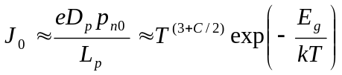 (‎B.13)

where C is a constant. The term T^{(3+C/2)} is negligible in comparison to the exponential term, leading to that ln J₀ is proportional to -1/T.

Effect of recombination on the Shockley equation
Under forward bias condition for a p-n junction which have localised traps in the depletion region, excess carriers (both electrons and holes) are injected in the depletion region, which increases the probability of their capture at traps, and therefore recombination. The recombination rate of the excess carriers U based on Shockley-Read-Hall (SRH) theory is given by [2],

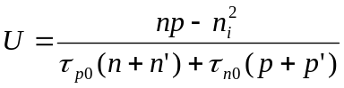 (‎B.14)

where n’ (p’) is the electron (hole) concentration that would be in the conduction (valence) band if the trap energy E_{t} coincided with E_{F}, n and p are the electron and hole concentrations in the conduction and valence bands respectively and _{n0} and _{p0} are the excess minority carrier electron and hole lifetimes respectively.
The forward applied voltage V can be expressed using E_{Fn} and E_{Fp} as (see Figure ‎B.2) [2],

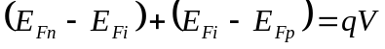 (‎B.15)

The complete recombination process requires that the trap captures an electron and a hole from the conduction and the valence bands respectively. Hence, the location of the trap within E_{g} affects the recombination probability taking place in it. The maximum recombination rate occurs, therefore, when the traps are located at E_{Fi} (middle of E_{g}) i.e. E_{t} = E_{Fi}, then n’ = p’ = n_{i}. This rate decays sharply as E_{t} moves away from E_{Fi}. By considering equation B.15, at the centre of the depletion region,

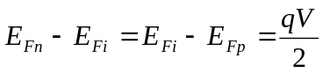 (‎B.16)

As a result, equations B.1 and B.2 then become

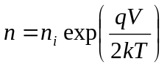 (‎B.17)

and

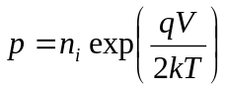 (‎B.18)

Recalling that n’ = p’ = n_{i} and _{n0} = _{p0} = ₀ for traps at the centre of depletion region, equation B.14 becomes

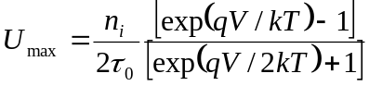 (‎B.19)

where U_{max} is the maximum recombination rate. If V >> kT/q then 1 can be neglected from both numerator and denominator, and then

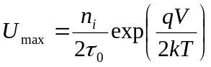 (‎B.20)

The recombination current under forward bias is then calculated from

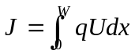 (‎B.21)

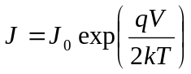 (‎B.22)

where

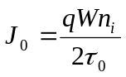 (‎B.23)

and W is the depletion width. Due to the relationship between n_{i} and T as seen in equations B.1 and B.2, ln J₀ may vary linearly with -1/T.
Under the reverse bias condition, generation current dominates rather than recombination due to the lack of excess carriers i.e. current is due to carriers which are thermally generated via traps. The reverse generation current has a similar expression to that of J₀ in equation B.23 [2], but with a minus sing due to its direction. Therefore the general equation for the current in a p-n junction having the features described above is

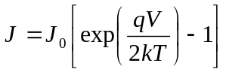 (‎B.24)

which is similar to equation B.11, describing the diffusion current, except that there is 2 in the denominator of the exponential power for this equation. Hence, current in the p-n junction can be described more generally by

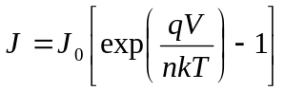 (‎B.25)

where n is the ideality factor, which is = 1 or 2 if the current is controlled by diffusion or recombination transport mechanisms respectively.

References for appendix B

[1] S. M. Sze, Physics of Semiconductor Devices, 2nd ed., A Wiley-Interscience Publication, New Jersey, (1981).
[2] D. A. Neamen, Semiconductor Physics and Devices Basic Principles, 3rd ed., McGraw-Hill, New York, USA, (2003).

